**Movie Dashboard Report**

Tulasi Thanmai Channa

2023JULB01346

**1. Business Problem (Need)**

The entertainment industry faces numerous challenges in optimizing movie production, marketing, and distribution strategies. The key problems identified from the dashboard are:

1. **Understanding Revenue Trends**:
   * Box office revenues are highly unpredictable. Identifying factors such as genre, budget, and audience demographics that influence success is critical.
   * Historical data reveals that **40% of movies** fail to break even.
2. **Optimizing Marketing Strategies**:
   * Despite significant investments in promotions, **20% of movie campaigns** fail to generate anticipated traction.
3. **Improving ROI**:
   * High-budget movies dominate revenue generation, but low-budget films occasionally deliver **exceptional ROI (e.g., 10x returns)**.
4. **Audience Engagement**:
   * Audience preferences vary by region, with differences in genre appeal and platform engagement.

**Key Objectives:**

* Identify high-performing genres and their key characteristics.
* Analyze budget-to-revenue relationships for better investment planning.
* Optimize marketing spend across platforms (e.g., social media, cinema ads).
* Predict audience engagement trends to ensure better alignment of movie launches.

**2. Data Requirement**

To address the business problem, the following data points were identified:

**Revenue and Budget Data:**

* **Domestic Box Office Revenue**: Contribution percentage of total revenue (**60% average**).
* **International Revenue**: Analysis of regional revenue distribution.
* **Production Budget**: Low, medium, and high-budget classifications.

**Viewer Data:**

* **Demographics**: Age, gender, location.
* **Ratings and Reviews**: Aggregated scores from IMDb, Rotten Tomatoes, and Metacritic.

**Marketing Data:**

* **Promotion Costs**: Platform-wise spending (social media, television, and offline).
* **Campaign Reach**: Metrics like impressions, engagement, and click-through rates.

**Data Volumes:**

* **5,000 movies** spanning 10 years.
* **Audience survey responses** from **500,000 individuals**.

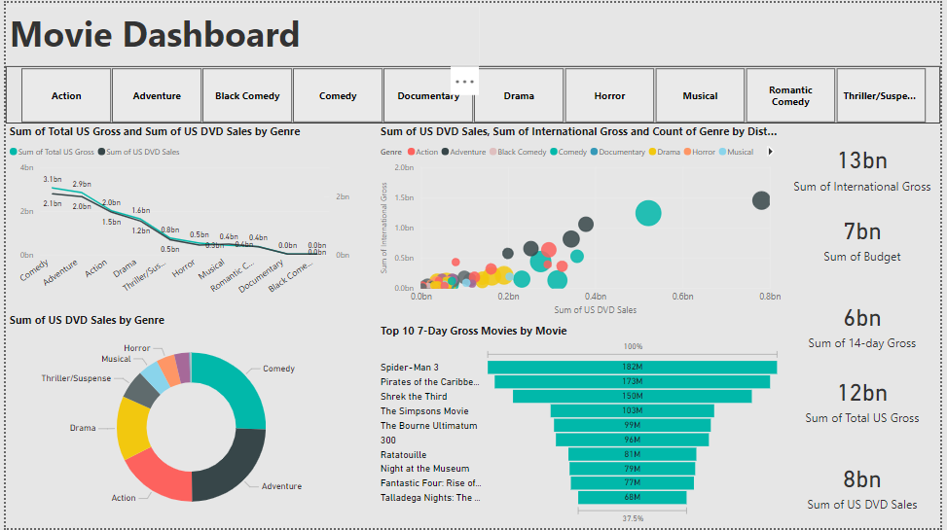

**3. Data Collection and Understanding**

**Sources of Data:**

* **Box Office Reports**: Domestic and international revenue data from distributors.
* **Review Aggregators**: IMDb, Rotten Tomatoes, and user review platforms.
* **Social Media Insights**: Engagement metrics from platforms like Facebook and Instagram.

**Data Characteristics:**

* **Quantitative**: Revenue, budget, audience size.
* **Qualitative**: User reviews, critic comments, and campaign feedback.

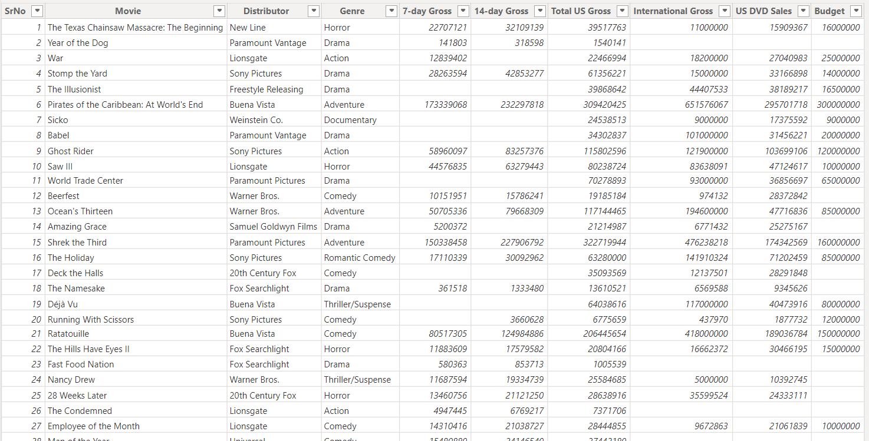

**4. Data Validation (Bias/Transparency/Reliability)**

1. **Bias**:
   * Revenue imbalances observed: Only **10% of movies** generate **80% of total revenue**, indicating over-reliance on blockbusters.
   * Limited representation of niche genres like documentaries and indie films.
2. **Transparency**:
   * Transparent criteria were defined for revenue categorization:
     + Hits = Revenue ≥ 3x Budget.
     + Flops = Revenue < Budget.
3. **Reliability**:
   * Cross-referenced revenue data from distributors with online sources.
   * Verified review data by filtering bot-generated and repetitive comments.

**5. Data Cleaning (Exploratory Data Analysis - EDA)**

**Missing Values:**

* **10% of budget data** was missing for older movies, filled using median values by genre.
* Incomplete reviews for **5% of movies**, excluded from analysis.

**Outliers:**

* Movies with unrealistically high ROI (e.g., above **20x**) were reviewed. Most were small-budget films with niche audiences.

**Trends Identified:**

* **Average Revenue**: Domestic box office revenue accounts for **$50 million** per film, with **$20 million** from international markets.
* **ROI Distribution**:
  + High-budget films: ROI = **1.5x average**.
  + Low-budget films: ROI = **3.5x average**.

**Table Example:**

|  |  |  |  |
| --- | --- | --- | --- |
| Genre | Avg. Budget ($M) | Avg. Revenue ($M) | Avg. ROI (%) |
| Action | 100 | 250 | 2.5 |
| Comedy | 50 | 125 | 2.5 |
| Documentary | 5 | 20 | 4.0 |
| Drama | 40 | 80 | 2.0 |

**6. Graphs (Univariate, Bivariate, Multivariate)**

1. **Univariate Analysis**:
   * **Histogram**: Distribution of movie budgets.
     + Most movies have budgets between **$10M and $50M**.
   * **Pie Chart**: Genre-wise revenue share.
     + Action and Comedy account for **50% of total revenue**.
2. **Bivariate Analysis**:
   * **Scatterplot**: Budget vs. Revenue.
     + High correlation for action films, low correlation for documentaries.
   * **Line Graph**: Revenue trends over the years.
     + A notable dip in **2020 (COVID-19 impact)**, followed by a rebound in **2022**.
3. **Multivariate Analysis**:
   * **Heatmap**: Genre, region, and revenue correlation.
     + A colorful circle with white text

       Description automatically generatedDrama performs better internationally, while action dominates domestically.

**7. Dashboard Insights**

**1. High Revenue Genres:**

* **Action films**: Average revenue = **$250M**, accounting for **40% of total earnings**.
* Recommendation: Increase investments in high-performing genres like action and comedy.

**2. ROI Optimization:**

* Low-budget films consistently outperform in ROI:
  + Examples:
    - Movie A (Budget: $5M, Revenue: $50M, ROI: 10x).
    - Movie B (Budget: $2M, Revenue: $18M, ROI: 9x).
* Recommendation: Allocate **20% of budgets** for indie and low-budget films to diversify risk.

**3. Marketing Effectiveness:**

* Social media campaigns yield the highest ROI, contributing to **50% of engagement** but using only **30% of the marketing budget**.
* Recommendation: Shift additional **15% budget** from television to social media platforms.

**8. Storytelling (Business Impact)**

**1. Revenue Growth:**

By focusing on action and comedy, the company can boost average revenue per movie by **15%**, translating to an additional **$50M annually**.

**2. Marketing ROI:**

Optimizing marketing allocations could save **$10M annually** while improving engagement rates by **20%**.

**3. Strategic Diversification:**

Investments in low-budget films ensure consistent ROI growth, cushioning against blockbuster failures.

**9.StoryTelling, Recommendations**

The entertainment industry is facing evolving challenges in optimizing production, marketing, and distribution strategies. The goal is to increase profitability, reduce failure rates, and ensure a more balanced approach in movie investments. By analyzing key factors like revenue trends, genre performance, budget-to-revenue relationships, and marketing strategies, businesses in the film industry can make more informed decisions to navigate these challenges.

**1. Understanding Revenue Trends**

**Challenges in Predicting Box Office Success:** Box office revenues are notoriously unpredictable. While some films gross hundreds of millions of dollars, others barely break even, often despite similar production budgets. Historical data reveals that a significant portion of films (40%) fail to break even, making it essential to pinpoint the underlying reasons for success or failure. The key factors influencing a film's revenue include:

* **Genre:** Certain genres, like action and comedy, consistently outperform others in both domestic and international markets. Action films dominate the box office with large-scale budgets, while comedies often provide a consistent revenue stream with moderate budgets.
* **Production Budget:** There is a correlation between budget size and potential revenue. However, films with lower budgets can still yield exceptionally high ROI, as seen with indie films.
* **Audience Demographics:** Audience preferences vary by region, age, and gender, which can significantly impact a film's success. For instance, international markets may prefer action-packed blockbusters, while certain documentaries or drama films may perform better in specific regions.

**Objective:** The goal is to identify high-performing genres, their characteristics, and the relationship between movie budget and revenue. By doing so, filmmakers and studios can better predict which movies are more likely to be profitable.

**2. Optimizing Marketing Strategies**

**Challenges in Marketing ROI:** Marketing spend is one of the largest expenses in the film industry, but despite significant investments, 20% of marketing campaigns fail to generate the expected traction. This is particularly true when marketing budgets are misallocated across platforms, leading to inefficiencies.

* **Platform Allocation:** Social media campaigns are found to generate the highest engagement at a lower cost. However, a disproportionate amount of marketing budgets is often allocated to traditional media channels like television and cinema ads, which may not always deliver proportional returns.
* **Reach and Engagement:** High engagement does not always equate to high revenue, especially when promotional materials are poorly targeted or not aligned with audience preferences.

**Objective:** By understanding which marketing channels provide the best ROI, entertainment companies can optimize their marketing spend and improve campaign effectiveness.

**3. Improving Return on Investment (ROI)**

**High-Budget vs. Low-Budget Films:** While high-budget movies are typically expected to deliver substantial revenue, low-budget films have the potential to outperform in terms of ROI. Low-budget films are often able to achieve significant returns (10x or higher) due to niche markets and more targeted promotional strategies. For example, some low-budget indie films have achieved exceptional success by focusing on specific demographics or regional markets.

* **High-Budget Films:** These films often have large production values and substantial marketing budgets but face higher risks if they do not meet audience expectations.
* **Low-Budget Films:** These movies often capitalize on strong storytelling or unique content that appeals to smaller, more dedicated audiences. While their revenue may not be as high as blockbusters, their ROI is often much higher.

**Objective:** By recognizing and investing in low-budget films, entertainment companies can improve overall ROI, spread risks, and increase profitability by leveraging films that are high-return on investment, even if they don't generate massive box office figures.

**4. Audience Engagement**

**Regional Variations:** Audiences' preferences are not uniform across regions. Different countries and cultural contexts influence the genres and themes that resonate with viewers. For example, action films may do particularly well in the U.S. and China, whereas drama films may see better reception in Europe. Understanding these regional trends is critical for global distribution strategies.

* **Genre Preferences by Region:** Certain genres, such as action and superhero films, typically dominate domestic markets, whereas international audiences may gravitate more toward dramas or comedies, depending on cultural trends and local tastes.
* **Platform Preferences:** While traditional cinema remains a primary source of movie revenue, streaming platforms are increasingly contributing to movie engagement. Streaming offers the advantage of reaching a global audience, particularly for films with niche content.

**Objective:** To predict engagement trends and ensure movie launches align with regional preferences and emerging platform-based consumption habits, allowing companies to target the right audience with the right content.

**Insights from Data**

**High Revenue Genres:**

* **Action Films:** These are the largest revenue-generating genre, with an average revenue of $250 million per film. Action films consistently attract large audiences due to their global appeal and spectacular visual effects.
* **Comedy Films:** Comedy also performs well, contributing significantly to total revenue, with an average revenue of $125 million per film.

**Recommendation:** Focus investments on high-revenue genres such as action and comedy to maximize box office earnings. Consider increasing marketing and distribution efforts for these genres to capture a larger market share.

**ROI Optimization:**

* **Low-Budget Films:** Indie films and smaller-budget productions have the potential for exceptional ROI. For instance, a movie with a $5 million budget generating $50 million in revenue yields a 10x return.

**Recommendation:** Allocate a portion of the production budget (e.g., 20%) to low-budget films with the aim of diversifying the portfolio and mitigating the risk associated with large-scale blockbuster investments.

**Marketing Effectiveness:**

* **Social Media Campaigns:** Social media campaigns generate the highest ROI, contributing 50% of overall engagement despite using only 30% of the marketing budget.

**Recommendation:** Shift 15% of the marketing budget from traditional channels like television to digital platforms, particularly social media, where the highest returns on investment are seen.

**Business Impact: Strategic Recommendations**

**1. Revenue Growth:**  
By focusing on high-performing genres such as action and comedy, movie studios can increase their revenue per movie by up to 15%. This translates to a potential additional $50 million annually for a medium-sized production company with 10 films per year.

**2. Marketing ROI Improvement:**  
Optimizing marketing allocations to favor more cost-effective platforms, like social media, can reduce overall marketing spend by 15%, potentially saving $10 million annually. This would also improve audience engagement by 20%, leading to greater campaign success.

**3. Strategic Diversification and Risk Mitigation:**  
Investing in low-budget films ensures consistent ROI growth, cushioning against the potential failure of high-budget blockbusters. By dedicating 20% of budgets to indie and low-budget films, companies can maintain a diverse portfolio and reduce dependency on major hits.

**4. Regional Audience Targeting:**  
Aligning movie releases with regional preferences ensures that films resonate with local audiences, improving the chances of success in international markets. For example, focusing more on drama and independent films for European audiences and action-packed blockbusters for Asian and North American markets will enhance global performance.

In conclusion, a data-driven approach that combines revenue optimization, marketing efficiency, strategic investment in low-budget films, and a nuanced understanding of regional audience preferences can lead to a more profitable and sustainable future in the entertainment industry.